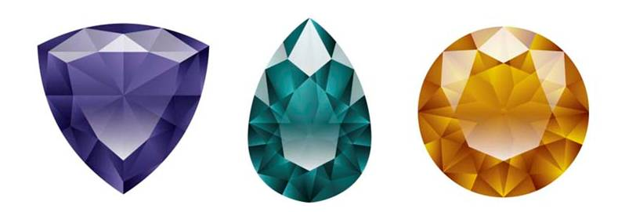


Certificate of Analysis

Product Name: |  | Crystel Diamond
Reference: |  | CRY/DIA/019
Batch Number: |  | 726200
Date of Manufacture: |  | 2017-09-19
Expiry Date: |  | 2019-09
This is to certify that Crystel Diamond solution above was tested on 2017-09-19 and found to comply with all requirements as set out in the specifications and method of analysis.

PROPERTIES | SPECIFICATION |  | RESULTS
APPEARANCE | Clear solution free of matter |  | Conforms
SPECIFIC GRAVITY | 1.030 – 1.050 |  | 1.036
pH (neat) | 8.0 – 9.0 |  | 8.5
STERILITY | No growth

Completed By: Reviewed By:

Quality Department: …………………………… ………………………………………………

Date: …………………………………………………… Date: ………………………………………

